SharePoint Online Help

# Add/Remove Users

## Navigate to SharePoint groups for a site

### SharePoint group

There are multiple ways to add a user to a group. Click on settings gear and click on “Site Permissions”

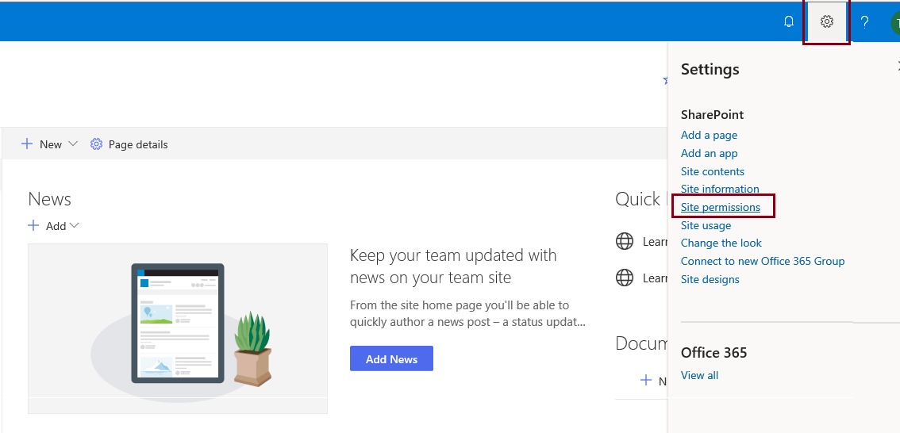

Click on ‘Advanced permissions settings’ which is present on window right side.

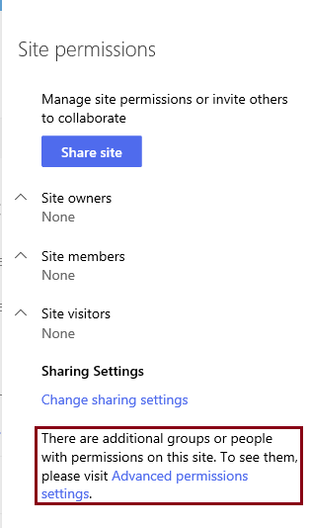

A list of SharePoint groups is present in below page. Click on a group name which you need to update.

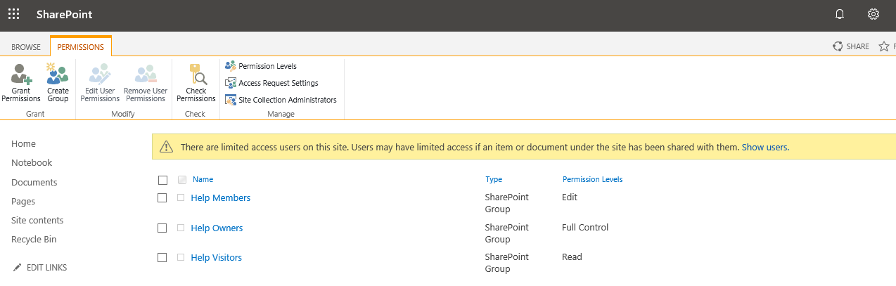

## Add Users

Click on New 🡪 Add Users



Enter names or email address in first text area. We can include personal message in second text area. Click on email invitation checkbox, if we want to send invitation through email and then share.

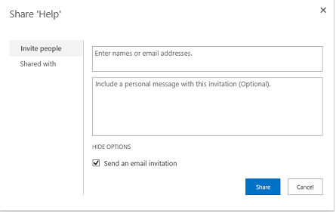

## Remove Users

Click on the user checkbox for which you want to remove him from SharePoint group.

Click on Action🡪Remove users from group as shown in below fig

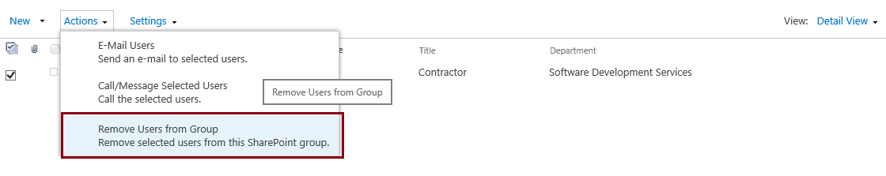

Click Ok once you receive message box. This will delete user from the group.

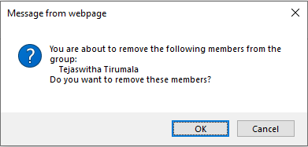

## Add External users to SharePoint Site

### SharePoint group

Below steps explain to add an external user (NYP user) to SharePoint site. Click on Site Permissions link.



Groups are divided based on the permission level.

[[Site Name]] Owners 🡪 Have Full Control access at site level.

[[Site Name]] Members 🡪 Have edit or contribute access at site level.

[[Site Name]] Visitors 🡪 Have just read access at site level.

Below image gives us a clear picture on it.

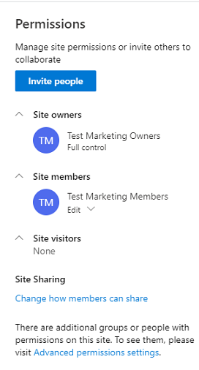

Here [[Site Name]] means ‘Test Marketing’

Click on the group where you want to add it. Below will explains the clear description of each tab.

About Tab 🡪 Gives clear explanation of this group. Also provides information of group email id and members which have access to the group.

Members Tab 🡪 Have access to look into list of members that are present and have access to add a new member to the group.

Email Tab 🡪 All recent conversations from this group were shown up in this tab.

## Add External Users

Go to Members tab and click on ‘Add Member’ link as shown in fig.

This will open in Outlook, where we can add external members. Click on ‘Add Members’ as shown in 2nd image.

Click add button after entering their email ids.

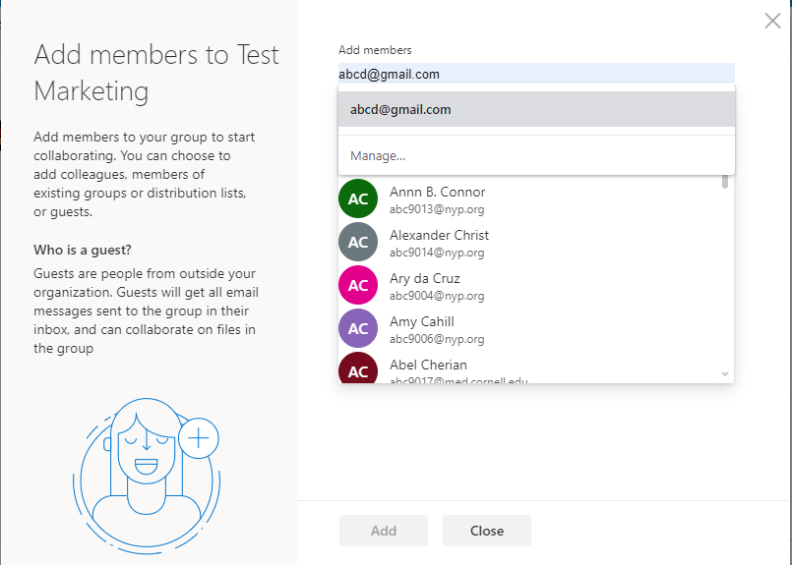

## Invite Others.

We can also invite others by clicking on ‘Invite Others’ link as shown in below fig.

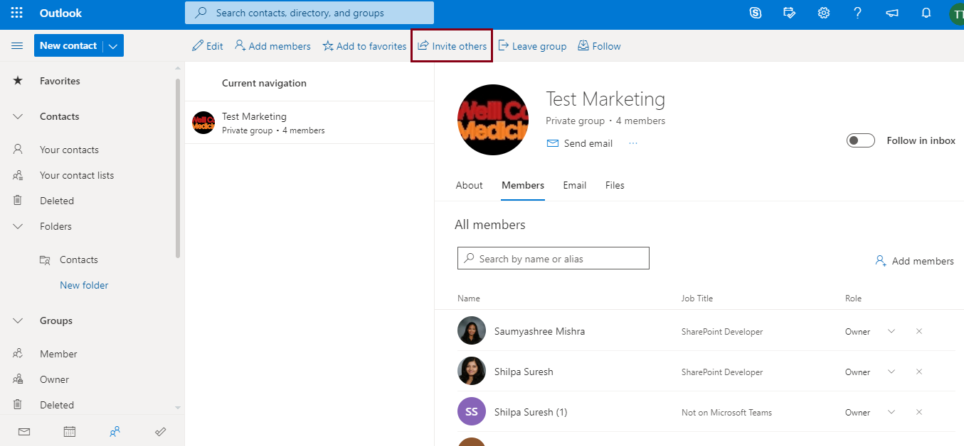

A pop-up window will open where we can send the invitation link through email or by other source by just copying the link.

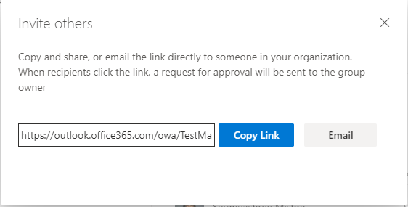

## Edit Group Settings.

We can change the settings of the group by just click on Edit group and change settings of the group.

